GLG494/598 (ASU) and GEOL 701J (UNR): Mapping tectonic faults from geomorphology
Fall 2020

Assignment 4: Mapping a normal fault in the western Basin and Range using lidar data and use of profile tool in QGIS.

Due: Wednesday September 23, 2020

This exercise is designed to get you to start thinking about how a fault system may change along strike resulting in changes in the width of deformation. Inspecting the image will give you an appreciation for the subtleties of fault geomorphology along one of the most active faults in the Basin and Range. Additionally, you will gain experience visualizing differences between the expression of faults in bedrock and Quaternary deposits. A summary of the Carson Range-Kings Canyon-Mt. Rose fault system is provided at the end of this document and a few references are provided.

Part 1. Download the provided DTM of the western side of Washoe Valley, Nevada that shows the Carson Range-Kings Canyon-Mt. Rose fault system. Generate hillshades of the DTM in QGIS as we did in homework assignment 2. Consult the QGIS tutorials on the class web site if you need a refresher. Illuminating the hillshade from the west will probably produce the best hillshade for mapping the fault, but feel free to try other angles and/or make a slope shade to give you different perspectives. Spend about an hour mapping the fault and tectonic features. Make a fault polyline shapefile to do this. Map faults along the entire extent of the map and pay attention to range front traces, traces within the bedrock, and parallel traces that might indicate wide zones of deformation. Be sure to qualify your faults by using different line types (solid = certain, dashed = approximate, dotted = concealed, and/or dotted with question marks = querried). Use abbreviations to show the locations of tectonic features as discussed in class (i.e. s = scarp, tf = triangular facet, g = graben, etc).
Deliverable: Turn in a screen shot of your map including a legend. You can make the legend in another program if you wish (word, illustrator, etc.). If your line work for the full map is not very legible in one screen shot, then zoom in and take two screen shots (southern half and northern half).

Part 2. Various plugins can be added to your QGIS toolbox. Install a profile tool. Open QGIS and click the plugins tab on the top toolbar. Select ‘manage and install plugins’ and enter ‘profiles’ in the search window. Several different profile tools have been developed, but I have had luck with ‘Profile tool’ and ‘qProf’. Click ‘install plugin’, an icon should appear on the toolbar. To generate a profile click the profile tool and open the profile window. Highlight the DTM layer in the layers menu and click ‘add layer’. Then click on the map to start the profile and double click to end it. You should see a smooth profile in the profile tool window. If not, make sure you have added the correct layer to the profile window (use the DTM). The screen shot below illustrates the tool. You can see the elevation difference across the profile along the Y axis. Additionally, you can hover the mouse over the profile line and a window showing the elevation should appear.

Once you have the plugin installed and familiarize yourself with how it works, you can start playing with drawing profiles across faults you have mapped. Try drawing some short profiles across discreet scarps and also some longer ones in areas with more distributed deformation.
Deliverable: Turn in screen shots of 3 profiles. Indicate the location of the 3 profiles on your map. One easy way to do this is to make a new polyline shapefile in QGIS titled ‘profiles’ and simply draw the location on the map.

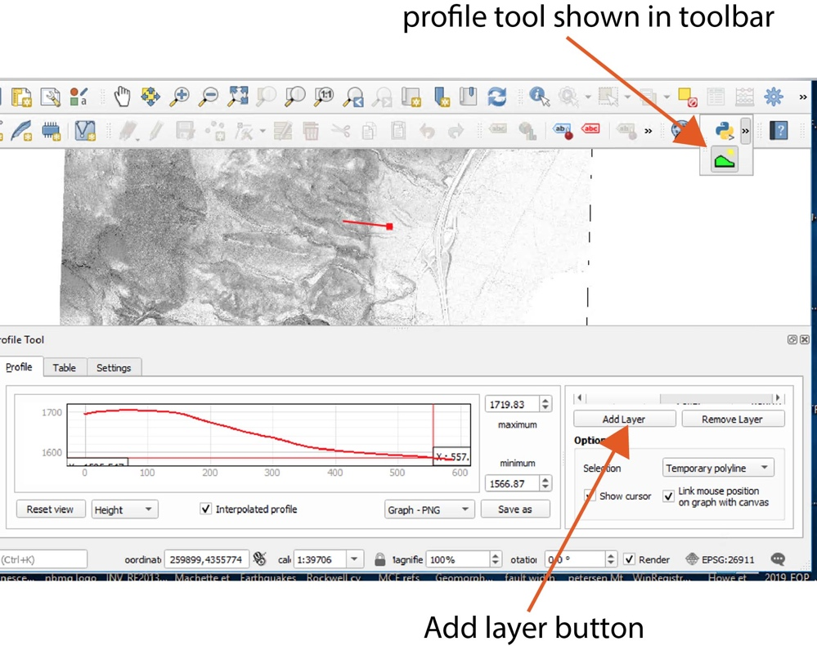

Part 3. Write a three-paragraph summary of your mapping and profile efforts including:
First paragraph - Describe the tectonic geomorphology that you observed to determine the locations of fault traces. Although you do not have to map individual deposits, you should also comment on the types of deposits that are faulted. There are a few major debris flow deposits, alluvial fans, and glacial outwash deposits. Can you recognize them by inspecting the topography? And can you describe the faults based on their relation to the deposits?
Second paragraph - Summarize the results of your profiles. How much offset is recorded in the landscape? Are there places where there is more offset than others and what might that mean? In places where the deformation is distributed, can you pose some ideas on why? Finally, given a slip rate of 0.4 mm/yr and an offset (displacement) measured in one of your profiles, can you estimate the age of a faulted deposit? Hint: slip rate x age = displacement.
Third paragraph – Describe how the expression of the fault and the width of deformation changes from south to north and provide an idea of why this might be . Hint: “in the south part of the map area the fault is characterized by......In the north part the fault is characterized by.....” Can you trace the fault through the entire map or are there places where it is not recognizable? Are there bends, steps, and/or parallel traces? Is the style of faulting entirely normal? What role might fault dip play?

Background on the Carson Range-Kings Canyon fault system

The Cason Range-Kings Canyon CR-KC fault system extends N12W for over 100 km along the eastern range front of the Carson Range from the vicinity of Woodfords in California to east of Spooner Summit in Nevada where it becomes partitioned into several splays near Carson City. The fault system has been variously named by different workers and has been referred to as the Genoa fault, Carson Range fault system, Carson Valley fault, and the Sierra Nevada frontal fault. North of Carson City, the system continues along strike as the Mt. Rose fault system which bounds the western side of Washoe Valley and projects into the Mt. Rose alluvial fan near Reno, NV. As one of the most active faults in the Basin and Range province, the system poses a high seismic hazard to the Reno/Carson City urban corridor.

The fault system (together with faults in the Lake Tahoe basin) generally coincides with the boundary between the Basin and Range province and the Cascade-Sierra Mountains province.
The Carson Range and Carson Valley are west-tilted structural blocks that may have split from the main Sierra Nevada block during the Plio-Quaternary, possibly in past 2.5 to 3 Ma (Birkeland, 1963). More than 2,000 m of down-to-the-east normal throw across the fault is indicated near Genoa by 1,500 m of range-front relief and some 500 to 1,000 m of adjacent basin fill (Ramelli et al., 1999).

The main CR-KC fault trace is marked by prominent tectonic geomorphology along its entire length. Late Holocene scarps are evident along the entire length of the system. Along the southern part of the fault, a flight of Quaternary glacial outwash terraces are displaced along the Carson River near Woodfords. Marine Isotope Stage (MIS) 6 deposits dated around 150 ka and MIS 2 deposits dated at 20.7 ka are vertically displaced 42-66 meters and 9-10 m, respectively (Rood et al., 2011; Wesnousky et al., 2016). Based on these observations, Rood et al. (2011) inferred a vertical slip rate of ~0.4 mm/yr. The section of the fault along Carson Valley is characterized by a steep rangefront with prominent rilled fault facets and fresh (little degraded) continuous scarps across late Holocene alluvial fans (Lawson, 1912; Ramelli et al., 1994).

Paleoseismic studies along the fault have been conducted in Washoe Valley. Near Whites Creek, Ramelli and dePolo (1997) excavated a trench across a 3.8-m-high scarp in glacial outwash deposits and inferred the occurrence of two faulting events. A trench 0.7 km north of the mouth of Ophir Creek across a 4-m-high scarp indicated the occurrence of two faulting events in the last 1700 years with about 2-2.5 m of vertical displacement in each event. The paleoseismic history along the Washoe Valley fault is similar to the history documented by studies along the Genoa fault to the south suggesting that large ruptures may have been synchronous along the range front.

References

Birkeland, P.W., 1963, Pleistocene volcanics and deformation of the Truckee area, north of Lake Tahoe, California: Geological Society of America Bulletin, v. 74, p. 1453-1464.

Lawson, A.C., 1912, The recent fault scarps at Genoa, Nevada: Bulletin of the Seismological Society of America, v. 2, p. 193-200.

Ramelli, A.R., Bell, J.W., dePolo, C.M., and Yount, J.C., 1999, Large-magnitude, Late Holocene Earthquakes on the Genoa Fault, West-Central Nevada and Eastern California: Bulletin Seismological Society of America, v. 89, no. 6, p. 1458-1472.

Ramelli, A.R., dePolo, C.M., and Bell, J.W., 1994, Synthesis of data and exploratory trenching along the northern Sierra Nevada fault zone: National Earthquake Hazards Reduction Program, Final Technical Report, 65 p., scale 1:100,000.

Ramelli, A.R., and dePolo, C.M., 1997, Trench and related studies of the northern Sierra Nevada Range-front fault system: National Earthquake Hazards Reduction Program, Final Technical Report, 21 p., scale 1:62,500.

Rood, D.H., Burbank, D.W., and Finkel, R.C., 2011, Spatiotemporal patterns of fault slip rates across the central Sierra Frontal fault zone, Earth and Planetary Science Letters, v. 301, pp. 457-468.

Wesnousky, S.G., Briggs, R.W., Caffee, M., Ryerson, R., Finkel, R., and Owen, L.A., 2016, Terrestrial cosmogenic surface exposure dating of glacial and associated landforms in the Ruby Mountains of Central Nevada and along the northeastern flank of the Sierra Nevada, Geomorphology, v. 268, p. 72-81.

